THE CHOSEN, Season 2, Episode 8

For Wednesday September 27
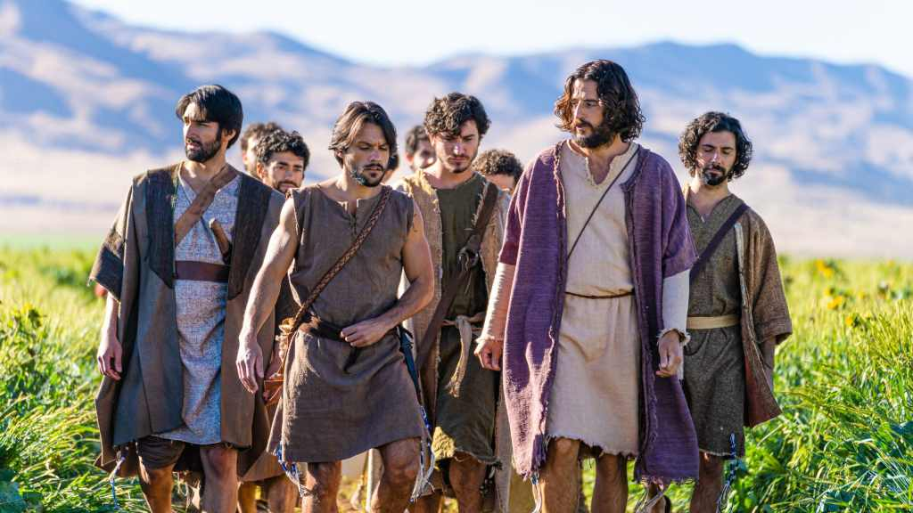
This is the finale of Season 2 and the episode centers on the sermon on the mount (recorded in Matthew 5-7).
The Pharisees continue to pursue their case against Jesus. Shmeul is asked for a list of Law violations that Jesus has committed. What does he come up with?
Do all the preparations for the sermon being made by the disciples and even Jesus Himself represent how you picture the Sermon on the Mount taking place? What is different from how you pictured it? What does the Bible say about all this? (Matthew 4:23-5:3)
According to the episode, how does Jesus describe the “Beatitudes”?
In this episode we are also introduced to Judas. How is his character developed? What kind of person is he? What is he interested in? Did you see any hints at what will become of him in the future?
Thanks for participating in this Bible study. Leave any thoughts, comments, or questions you have in the reply box below. Join us Wednesday night at 7 pm, in person or online, for a review of this material.

