THE CHOSEN, Season 3 Episode 1
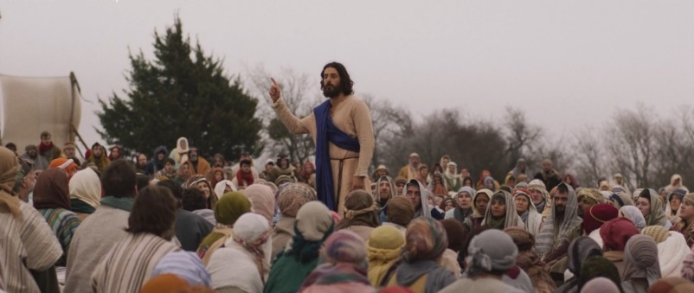
After a flashback to when Matthew was rejected by his family for being a tax collector, this episode presents the Sermon on the Mount. As you watched the sermon, what words of Jesus caught your attention?
As the multitudes leave the sermon the comments being made by those in attendance are interesting. Did anything stand out to you?
Next there is a brief gathering of Jesus’ followers before the group takes some time off. Jesus thanks everyone for their help and says goodbye with a prayer. What prayer does he use?
At this time we are also presented with Jesus meeting Judas and calling him to follow him. In a later scene we see Judas saying good by to his sister. What are your thoughts on the development of this important character? Are there any indications of how Judas will later betray Jesus?
After the sermon we are also introduced to Joanna. Read about her in the New Testament in Luke 8:1-3. Joanna arranges for Andrew to meet with John the baptizer in prison. If possible watch this meeting in prison carefully. What are your thoughts about the way John is presented?
Part of the sermon on the mount is Jesus statement, “Therefore if you bring your gift to the altar, and there remember that your brother has something against you, “leave your gift there before the altar, and go your way. First be reconciled to your brother, and then come and offer your gift” (Matthew 5:23-24). Who among the disciples took this to heart and what did they do?
As the episode ends, Matthew is reconciled to his father. Why do you think his father has chosen to forgiven him?
Thanks for being a part of this study! We will review this material together, in person and online, Wednesday October 4 at 7 pm.

