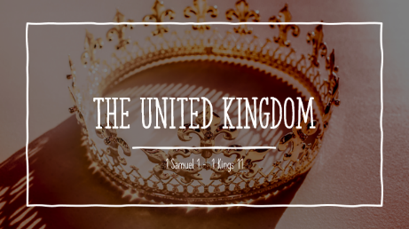

LESSON 12: DAVID THE WARRIOR KING
Reading: 2 Samuel 8, 10, 1 Chronicles 12 and 2 Samuel 23
__________________________
Questions:
2 Samuel 8
What army did David defeat in….
2 Samuel 8:1
2 Samuel 8:2
2 Samuel 8:3
2 Samuel 8:5
2 Samuel 8:13
How do you explain what David does to the Moabites in 8:2? What about the horses in 8:4?
What kind of administration did David lead according to 2 Samuel 8:15-18?
2 Samuel 10
What quality of David do you see in 10:1-2?
How do the princes of the people of Ammon respond to David’s act of kindness? (10:3-4)
So, what does David do? 10:5 – end of chapter.
1 Chronicles 12
1 Chronicles 12 describes David’s army. What does 12:2 say about the identity of the first group of soldiers?
Browse over the description of David’s armies. What do you see about their military skills?
How is David’s army described in 1 Chronicles 12:22?
How does 12:40 describe the state of the nation after David assembled his great army?
2 Samuel 23
There is another list of David’s warriors in 2 Samuel 23, compiled near the end of David’s life. Browse over this list and note some of their great feats, but notice especially: who is the last man in the list?

