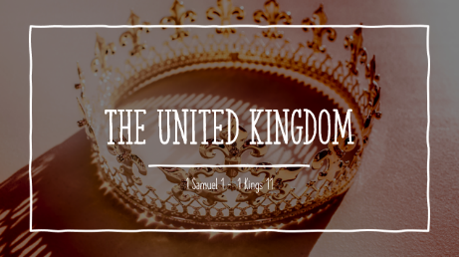

LESSON 20 – DOWNFALL and DEATH of SOLOMON
1 Kings 9-11
Summary
1 Kings 9 – God appears a second time to Solomon; Details of Solomon’s Physical Accomplishments.
1 Kings 10 – Queen of Sheba visits Solomon, More about Solomon’s Prosperity.
1 Kings 11 – Solomon’s Wives and Idolatry. Solomon Judged By God for Idolatry. Adversaries of Solomon. Solomon’s Death.

Questions:
What two paths does God present to Solomon? (1 Kings 9:1-9)
How impressed was the Queen of Sheba with the wealth and wisdom of Solomon? (1 Kings 10:5-10)
Browse over 10:10-29. What stands out to you about the prosperity of Solomon?
Solomon married foreign women but what additional sin did this lead to? (1 Kings 11:4-8)
What would be the punishment for Solomon’s sin? (1 Kings 11:11-13)
Who were the adversaries of Solomon? Who would take part of his Kingdom? (1 Kings 11:14-40)
What are your thoughts on the final statements about Solomon in the book of 1 Kings 11? Where is he spiritually as far as what 1 Kings and 2 Chronicles have to say?

.

