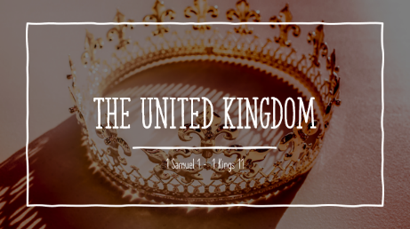

LESSON 18
Summary
1 Kings 2 - (Beginning in v12) Solomon deals with Adonijah, Abithar, Joab, and Shemei
1 Kings 3 - Solomon marries daughter of Pharoah, Solomon’s prayer for wisdom and Solomon’s wisdom demonstrated.
1 Kings 4 - Solomon’s Administration, Prosperity of Solomon’s reign, Wisdom of Solomon.
.

Questions
What is the status of Solomon’s kingdom as chapter 2 ends? What did he do in chapter 2 to accomplish this? ‘
Why did Solomon execute Adonijah (his half brother)?
Solomon said Abithar was deserving of death but he did not execute him. Why?
What is good about Solomon’s prayer (God thought it was) in 1 Kings 3:6-9?
What did Solomon’s decision in the case of the two harlot mothers demonstrate to Israel? (see end of chapter 3).
How do 4:1, 20-21, 25 describe the state of affairs in Israel at this time?
What warnings did Moses give about the behavior of Kings in Deuteronomy 17:16 and 17; How did Solomon do in this regard. See also 2 Chronicles 1:14-17.
How is the beginning of Solomon’s reign different from that of Saul or David?

