THE CHOSEN, Season 3, Episode 6
Lesson for Wednesday November 8

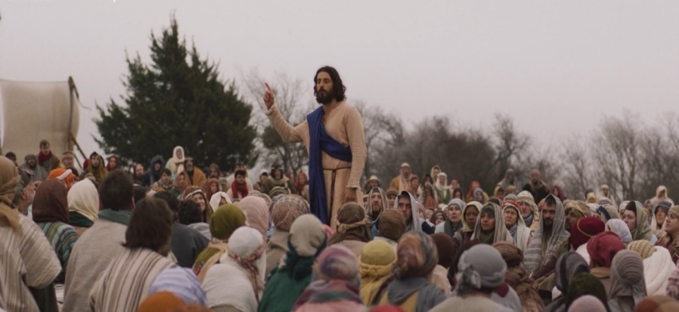
For this study watch The Chosen, Season 3, Episode 6, “Intensity In Tent City”.
The episode begins with an introduction to Pilate and his wife. What was Pilate’s wife dreaming about? Later in the episode, we see more of Pilate. Does his portrayal align with your expectations?
In the second scene, the apostles are seen sharpening their weapons and engaging in conversation. Do the frequent jokes in their dialogue feel plausible? What serious topics are they discussing?
What command did Quintas give Gaius? By the completion of this episode has he done what Quintas commanded? How serious would it be to have failed to complete what he was told to do?
Discuss how Mary Magdalene and Tamar turn a corner in their relationship.
The main subject in this episode is the disciples of John the Baptist who were sent by John to Jesus. This is found in Luke 10:1-18. What question do they come with? In this scene, a big crowd gathers around Jesus as he is working miracles. Who all is gathered in this scene witnessing the miracles and hearing Jesus answer to the question?
Some of Simon the Zealot’s former companions had come to hunt him down for being a traitor to the cause of the Zealots. Simon tries to explain to them that the Kingdom and Messiah has come, but it is different from what they were expecting. In the end, what do they say has happened to Simon?
Who is healed after the crowd was dispersed?
The episode concludes with Peter and Eden, with Eden finally sharing her tragic miscarriage. There has been much joy of healing in this episode, but this scene reminds us of a troubling question. What is the unsettling question that lingers? (Hint: the last words of the episode could be the answer but it is even deeper than that. Another hint: John the Baptist could have been asking the same thing. Another hint: Little James could have asked the same question.)
Thank you for joining our study! We look forward to reviewing this material together on Wednesday night, both in person and online at 7 pm.

