THE CHOSEN Season 3 Episode 7
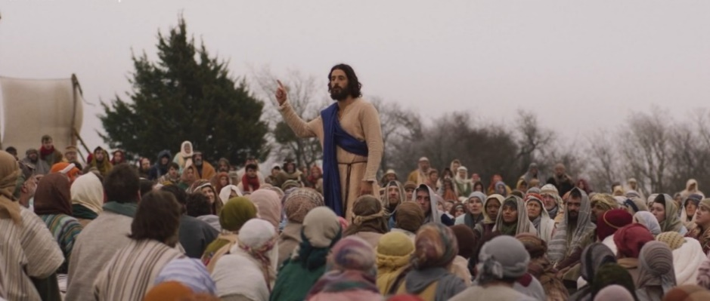
This episode is entitled “Ears To Hear”.
Note the contrasting emotions in the opening scene. Why are some rejoicing? Who is distraught?
THE DECAPOLIS
This episode revolves significantly around the controversy sparked by the preaching of the apostles in the Decapolis. A scene addressing the matter is entitled “We Caused A Multinational Crisis.” To better understand the issue, let’s delve into a few questions. What exactly is the Decapolis, and what factors led to the upheaval caused by the work undertaken there? In teaching at the Decapolis, the apostles employed a specific parable according to The Chosen (Luke 14:16-24). Why was this parable, and the choice to use it, considered risky?
How does Philip us Isaiah 42 to further thought among the apostles about these questions?
What point, related to the genealogy of Jesus, does Judas make concerning the matter?
GAIUS
What did we learn about Gaius’ family that further explains his interest in Jesus?
MATTHEW’S TASSELS
An intriguing scene in this episode contains a flashback where Matthew, the tax collector, encounters an older character who shares the same name. During this encounter, the older Matthew presents a gift to the younger Matthew. What are your thoughts on the identity of this mysterious character and the reasons behind his actions? What was Mary Magdalene’s perspective on the significance of the gift given to Matthew?
JESUS COMES TO THE DECAPOLIS
The Biblical text for the work in the Decapolis is found in Mark 7:31-37 and Matthew 15:29-31. What similarities or dissimilarities do you see in the way this is presented in The Chosen?
PETER’S STRUGGLES
What lesson do you take away from the fact that Peter, with all his struggles and questions, is chosen by Jesus to play an important part in the work that is being done?
Thank you for being a part of our Bible class! We invite everyone to a discussion about today’s lesson on Wednesday night at 7 pm. You can join us either in person at the Lakeshore building (1796 Old Middleburg Road) or online via Facebook Live.

