THE CHOSEN, Season 3, Episode 5
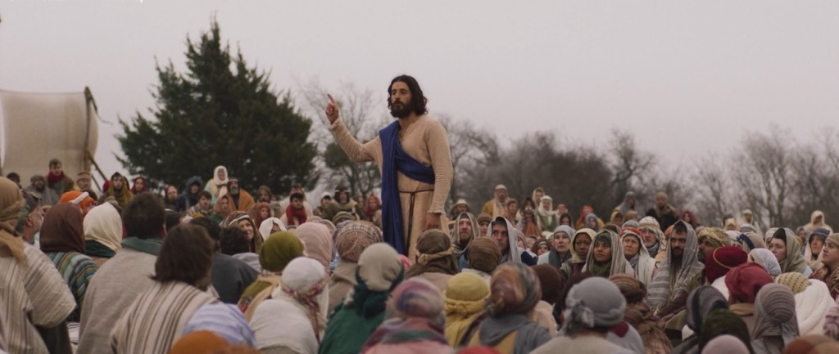
This is a continuation, part 2, of last week’s episode entitled “Clean”. Last time we were introduced to the woman who had been suffering with a bleeding issue as described in Mark 5:22-43, and we also earned more about Jairus. The miracles performed for them are the main topic of this episode.
Beginning with the opening scene, and throughout this episode, what burden is Eden dealing with? Is there anything in scripture to indicated something like this happened to her?
What did Zebedee say he, and his father before him, had been waiting for?
What role does Judas play in this episode?
Describe the interactions between Gaius and Peter. Does it seem plausible? What kinds of things do they discuss.
Another teaching illustrated in this episode is that of Mark 2:18-22 concerning fasting. Read this text and compare it to the presentation.
The central theme of this episode revolves around two miracles, both intertwined in Mark 5:22-43.
How did you feel about the way these miracles were presented? How well did the movie line up with the Biblical account? How do both Jairus and the woman (Veronica according to the series) show great faith.
What inspired the woman to look for Jesus? How can that be a lesson for us?
The episode ends with Jesus and the 12, and Veronica all frolicking in the Sea of Galilee! What is the significance of this and how does it tie in with the themes of the episode?

