THE CHOSEN #2
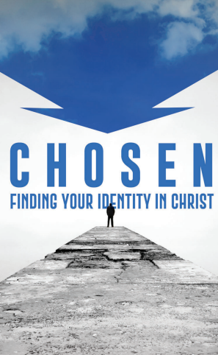
Season 1, Episode 2
Episode 2 is about the Sabbath. Read about the Sabbath in Genesis 2:1-3, Exodus 20:8-11, and Deuteronomy 5:12-15.
Why do we not observe the Sabbath today?
In this episode we also see the new Mary! What is different about her? Nicodemus is especially surprised and excited to find her healed and in her right mind! He wants to know how she was made well, assuming it was his exorcism that accomplished it. What question will Nicodemus later ask Jesus in John 3:1-2?
The episode progresses toward 4 Sabbath meals (at the houses of Mary, Peter, Nicodemus and Matthew’s parents).
Whose Sabbath meal did Jesus attend?
Who does Matthew share Sabbath with?
What tension was there at the Sabbath meal at Peter’s house?
Who did Mary set an extra seat for at her Sabbath meal table? Who filled the seat?
What scripture did you hear read at all the Sabbath gatherings? What ideas do you have about why they read this one?
What do you learn from Mary about how we should respond the salvation God has given us? Consider especially her efforts to provide a suitable Sabbath meal.
Think about the attitude of hospitality shown in the Sabbath meal gatherings. What gatherings do we have that are similar to the Sabbath meals illustrated in this episode? How are Sunday afternoon’s different today from the way they were in the 60’s and 70’s? What can we learn from the love and hospitality pictured in these Jewish homes?
Please share any thoughts you have in the reply box below. We will meet in person and online Wednesday June 14 to review this material together.

