THE CHOSEN, Season 2, Episode 5
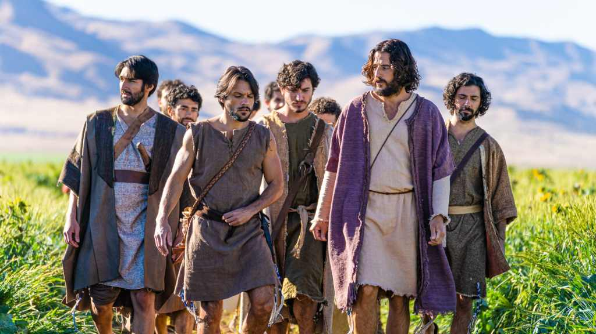
Due to the Hurricaine, this lesson will be reviewed September 6.
Some of the interesting storylines in this week’s episode are:
The Pharisee’s investigations of the invalid man’s healing at the pool of Bethesda.
The call of Simon the Zealot.
The relapse of Mary Magdalene.
Jesus visitng with John the Baptist, and……
Demon Possession
Another main theme is the idea of demon possession and the casting out of a demon. The New Testament records several times when Jesus cast out demons. Study Luke 4:33-35 for an example. How does the way The Chosen portrayed the casting out of the demon compare with the scripture and how did it cause you think about this phenomenon?
Concerning Simon the Zealot:
Simon is curious as to why Jesus healed his brother (at the pool of Bethesda). What was Jesus response?
What do you think of the way Simon is portrayed?
When Simon says “I will do anything for you” to Jesus, what does Jesus ask Him to do? How does Jesus then illustrate to Simon that the nature of his mission is not was Simon is expecting?
Concerning Mary:
The Bible does not tell us Mary Magdalene experienced any kind of relapse, but it is certainly possible for any of us. What thoughts did you have as you watched the portrayal of her going back to her old life?
What is the Old Testament verse that the disciples, including Mary Magdalene, have been learning and quoting that may be especially important as Mary wanders away from Jesus?
Jesus and John:
What are some of the topics discussed between Jesus and John?
How do their “styles” of ministry contrast with each other?
What matter is John urgently going to Jerusalem to address?
Why do you think Jesus cried as John walked away?

