THE CHOSEN, Season 3, Episode 2

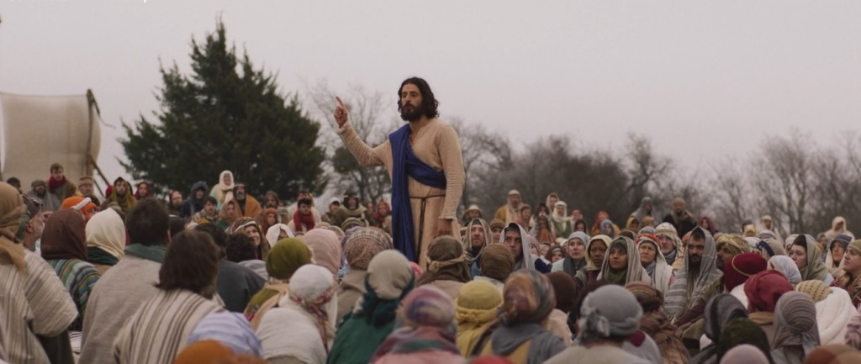
What concerns do the Romans have about the growing numbers of people following Jesus? What report do Gaius and Atticus give to Quintas about the Sermon on the Mount?
How does this episode explain the reconciliation that has taken place between Matthew and his family?
The main focus of episode 2 is Jesus meeting with the 12 and sending them out. This based on Matthew 10. Read this chapter and watch the video beginning at the 35 minute mark. What references to Matthew 10 do you see?
What instructions in Matthew 10 apply to us today?
What concern does “Little James” have before being sent out? What does Jesus say in His response that is helpful?
What Psalm do the apostles recite before beginning their mission? Who appears to be leading them?
Thanks for participating in our class! We will review this material in person (1796 Old Middleburg Road North) and on Facebook Live (see link below) Wednesday October 11 at 7 pm.

