As Jesus Died On The Cross…
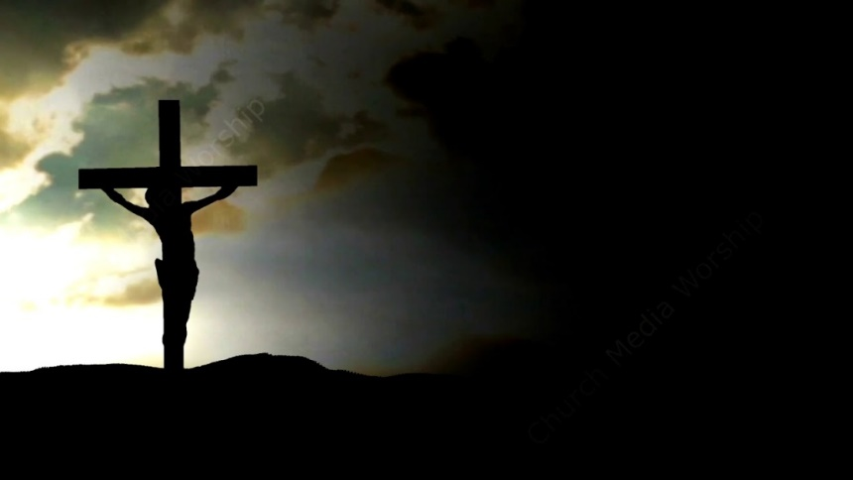
Lesson for June 8, 2022
Matthew 27 tells us about 3 remarkable things that happened as Jesus was dying and after he died on the cross. These testify in powerful ways to the significance of His death.
Darkness
Describe the darkness that occurred when Jesus died. Does this sound like a solar eclipse?
Why is 3 hours of darkness appropriate for what was happening at Calvary?
Veil of the Temple
What was the veil of the temple? What happened to the veil of the temple? When did this happen?
An earthquake could cause something like this to happen but the significance is so great regarding this we know it is more than coincidence!
What do these verses teach about the spiritual significance of the Most Holy Place in the Jewish Temple? Exodus 26:31-33, Leviticus 16:2, Hebrews 9:7-8.
What message did the tearing of the veil send? (See Hebrews 10:19)
Earthquakes and open graves
We can imagine an earthquake opening graves but what is the truly surprising part of this report?
Note carefully: when did the “saints” appear in the holy city (v53)
What would you say is the significance of this event?

