What If Jesus Had Come Down From The Cross?
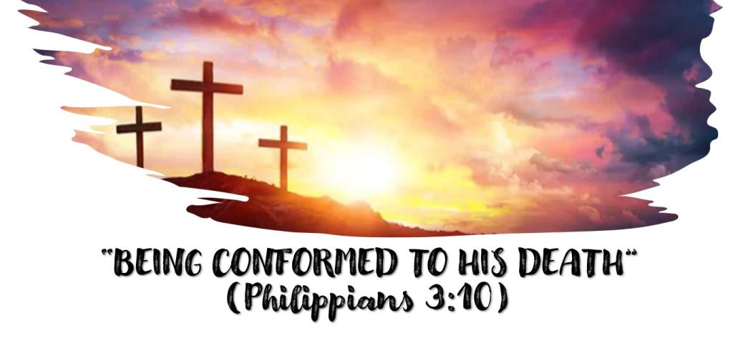
This is our last lesson (for now) on the cross.
When Jesus was dying on the cross they mocked Him saying, “He saved others; Himself He cannot save” (Matthew 27:42). The fact is, He did save others and He could have saved Himself (Matthew 26:53-54).
Where would we be spiritually if Jesus had come down from the cross?
What was the real temptation Jesus struggled with in the garden?
We think of the cross as a victory for Satan but did Satan really want to kill Him?
THIS IS ANOTHER WAY THAT WE ARE TO BE CONFORMED TO HIS DEATH
We are to take up our cross daily and follow Him (Luke 9:23). The idea of cross bearing is the idea of suffering. How does the flesh suffer when we resist temptation? (1 Peter 4:1).
How can we avoid that suffering?
Does Satan want us to endure that suffering now?
What happens if we refuse to bear our cross or if we come down from our cross? What will be the immediate affects on our flesh? What will be the effects on our relationship with God?
Jesus is our example. Hebrews 12:2 looking unto Jesus, the author and finisher of our faith, who for the _____________________ that was set before Him _________________________ the cross, despising the shame, and has sat down at the right hand of the throne of God.

