The Cross Teaches About Resisting Temptations
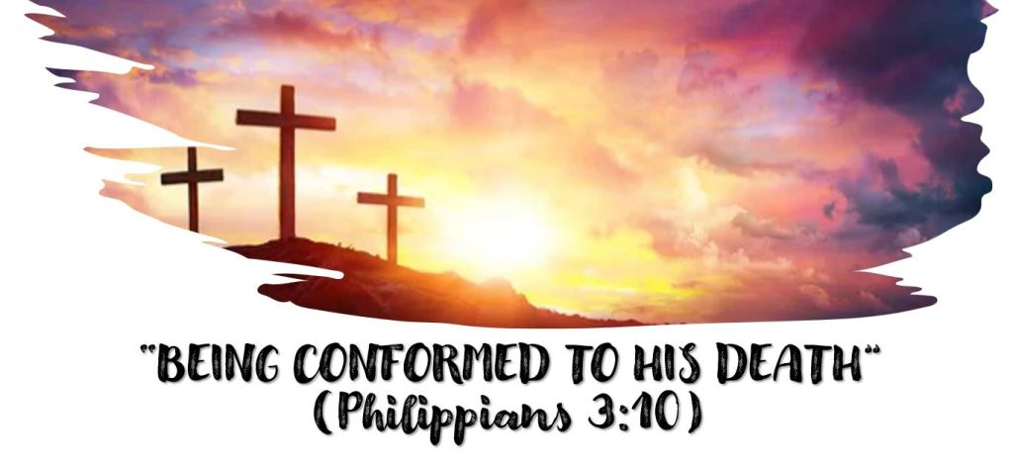
Christians are to follow the example of Jesus! Romans 8:29 tells us that it is God’s will that we be “conformed to the image of His Son”.
What part of the life of Jesus in particular does Philippians 3:10 tell us that we are to conformed to? What does this phrase mean to you?
The theme of our class is “The cross is not just something we are grateful for, it is an _________________________ that we are to follow”.
WHAT THE CROSS TEACHES ABOUT RESISTING TEMPTATIONS
Texts: Matthew 26:36-46, 1 Peter 4:1-4, 1 Peter 5:8-10.
What area of Christian behavior is Peter especially concerned with in 1 Peter 4:1-4?
What phrase in 1 Peter 4:1 suggests that we are to follow Christ’s example in resisting temptation?
How does resisting temptation cause suffering in the flesh? How would resisting temptation to gossip, for example, result in suffering in the flesh?
What temptation was Jesus facing when he went to the garden of Gethsemane?
Jesus experience in the garden of Gethsemane and our struggles with everyday temptations are of course very different in so many ways, but in what ways are they similar? In what ways are the different?
Review the “process” we talked about recently in 1 Peter 5:8-10 of how God gets us through the times when our adversary the devil tempts us. What promise is made to those who “resist Him, steadfast in the faith”?
How do you see Jesus going through this same process?
How did God answer Jesus prayer in the Garden?
How did he answer His prayer 3 days later?
We will face temptation. Our adversary the devil is “walking about like a roaring lion seeking whom he may devour”. How can we follow Christ’s example?
Leave any thoughts, comments, or questions in the reply box below. Join us Wednesday night at 7 pm on Facebook Live for a review of this lesson.

