The Cross Teaches About Obedience
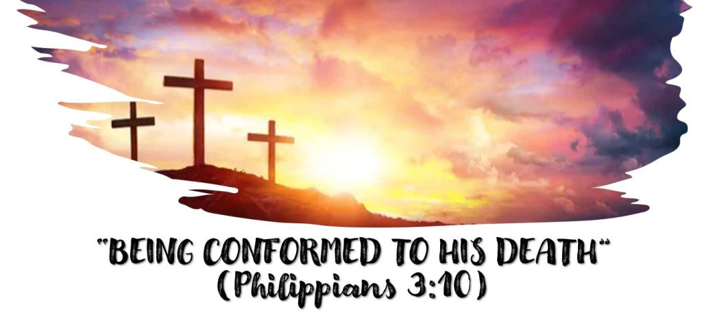
Our theme: The cross is more than just something that saves us and for which we are to be thankful…it is also an ______________________ that we should follow. We are to be __________________ to His (Christ’s) death (Philippians 3:10).
Jesus attitude and behavior in dying is a model for us to follow in many areas of our lives. We have already considered how the cross teaches about….
Love
Temptation
Unity
Giving
Evangelism
Loneliness
Being Mistreated.
THE CROSS IS AN EXAMPLE OF OBEDIENCE
Our Text: Hebrews 5:7 “….in the days of His flesh, when He had offered up prayers and supplications, with vehement cries and tears to Him who was able to save Him from death, and was heard because of His godly fear, 8 though He was a Son, yet He learned obedience by the things which He suffered. 9 And having been perfected, He became the author of eternal salvation to all who obey Him,
This is very similar to an earlier lesson on temptation. What is the relationship between temptation and obedience? How are the words different? How are they related?
Jesus was committed to obedience (Ecclesiastes 12:13, Hebrews 10:5-7). How does He express it in John 4:34?
How does Philippians 2:8 describe Jesus’s obedience?
Has there ever been a more difficult commandment that what Jesus was commanded to do?
Analyze Hebrews 5:7-9:
We are familiar with the “prayers and supplications, cries and tears” Jesus offered in the garden. The text says God heard Him.
Why does it say God heard Him?
What was God’s answer to Jesus’s prayer in the garden? In what sense could it be said that God heard Him?
What did Jesus obedience do for us?
Who receives the benefit of the death of Jesus?

