The Cross Teaches About Death
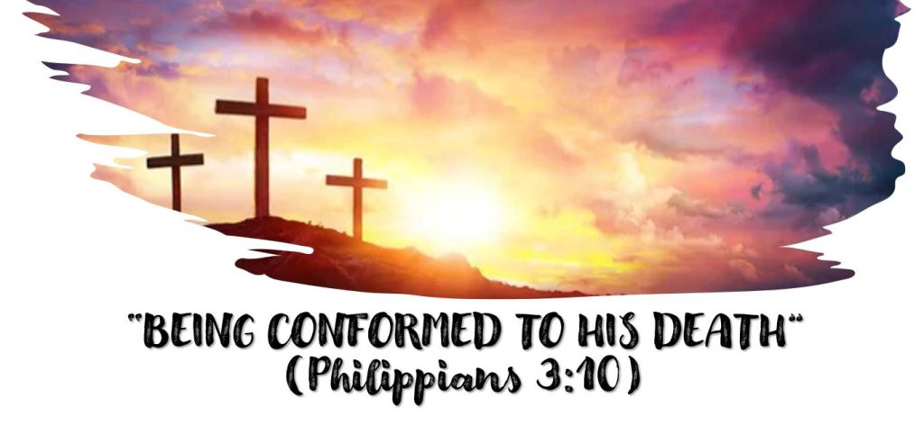
Luke 23:44 Now it was about the sixth hour, and there was darkness over all the earth until the ninth hour. 45 Then the sun was darkened, and the veil of the temple was torn in two. 46 And when Jesus had cried out with a loud voice, He said, “Father, ‘into Your hands I commit My spirit.'” Having said this, He breathed His last. 47 So when the centurion saw what had happened, he glorified God, saying, “Certainly this was a righteous Man!”
Jesus gives us a beautiful example to follow in dying when he says “Father into Your hands I commit my spirit”.
How is Jesus’ moment of death described in Mark 15:37? What about Matthew 27:50?
What does it mean to commit something to someone or into someone’s hands? What would be another word for commit? (Note the use of the word in 1 Peter 2:23 and 1 Peter 4:19.)
How is death described in the following verses?
James 2:26
Luke 8:55
Ecclesiastes 12:7
In light of these first two questions, what then is Jesus saying when he said “Father into your hands I commit my Spirit”?
Can we say the same thing when we die?
What assurance do we have about death in Romans 8:38-39? What other scriptures comfort you concerning death?

