The Cross Teaches About Being Ashamed

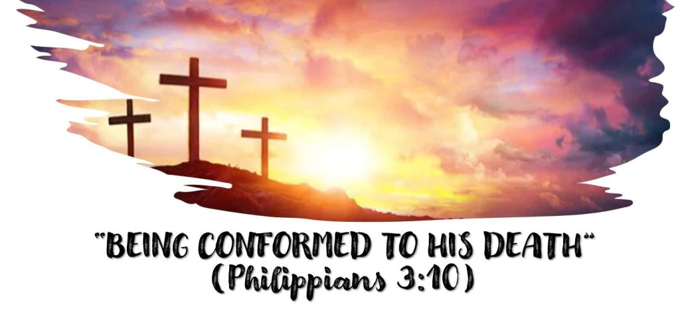
A song we often sing during the Lord’s Supper calls the cross “an emblem of suffering and shame”.
How do these verses speak to the shame associated with the cross and especially Jesus’s death on the cross?
Galatians 3:13.
Deuteronomy 21:22-23
Isaiah 53:3-4
How concerned are people generally with how they look to others?
If it is something people look on unfavorably, what are we tempted to do?
Is there anything about being a Christian that would cause the world to look at us unfavorably?
Instead of shying away from such situations, what should we do?
How does Hebrews 12:1-2 tell us Jesus handled the shame and reproach associated with the cross?
How can we do the same?
Share any thoughts you have in the reply box below! Join us Wednesday night at 7 on Facebook Live for a review of this material.

