THE CHOSEN, Season 2, Episode 1

For August 3, 2023
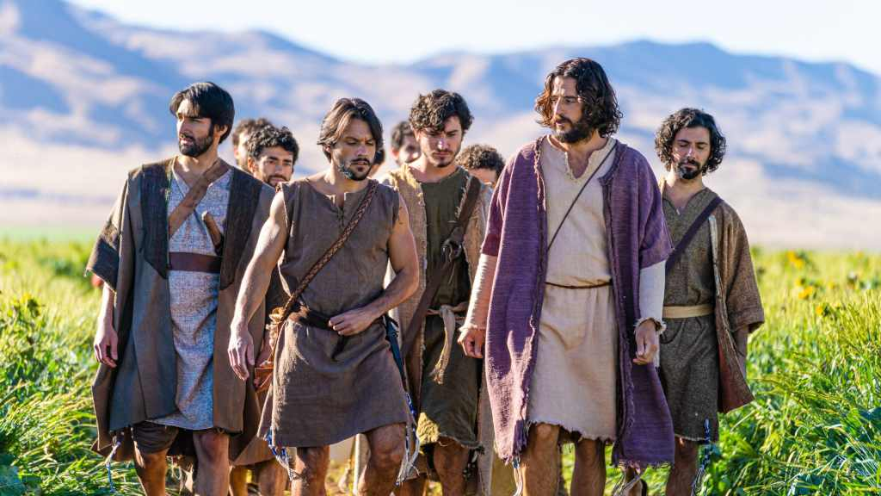
For this study try to watch season 2 episode 1.
Season 1 closed with the Samaritan women running to her city to tell everyone she had met the Christ. The Bible tells us that Jesus stayed 2 more days in Samaria: “And many of the Samaritans of that city believed in Him because of the word of the woman who testified, “He told me all that I ever did.” So when the Samaritans had come to Him, they urged Him to stay with them; and He stayed there two days. And many more believed because of His own word. Then they said to the woman, “Now we believe, not because of what you said, for we ourselves have heard Him and we know that this is indeed the Christ, the Savior of the world.” Now after the two days He departed from there and went to Galilee” (John 4:39-43).
This week’s lesson is a description of some of the things that might have happened while Jesus was in Samaria. It deals with the prejudices of the disciples and also the rivalries that developed among the followers of Jesus.
What lessons does The Chosen use the character of the Melech (a crippled “bad” Samaritan) to teach? What Bible stories and scriptures does he remind you of?
Much of this episode centers on division among the disciples. What are some of the things they disagree about? Compare the accounts of their arguing in the gospels: Luke 9:46-48, Luke 22:24, Mark 10:35-41.
For the Bible basis of the character of James and John see Mark 3:17 and the story in Luke 9:49-56. What does Jesus say about a man’s passion?
What else do we learn about John from John 13:23?
How is Matthew 10:35-37 reflected in this episode?
How can we apply the saying, “Don’t burn bridges, plant seeds” today?
Share any thoughts you have in the reply box below. Join us Wednesday night, in person or online, for a discussion of this material.

