THE CHOSEN, Season 3, Episode 3
For Wednesday October 18, 2023

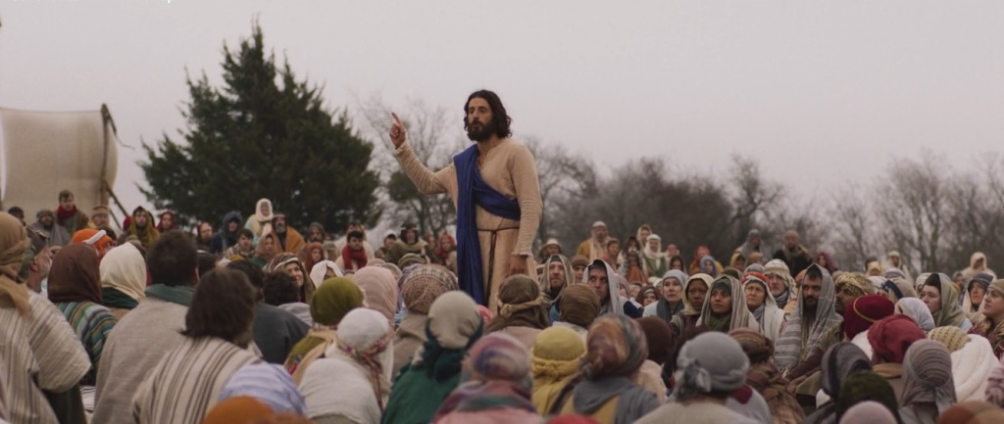
This week’s episode (Season 3, Episode 3) is called, “Physician, Heal Thyself”, and centers on Jesus visiting the synagogue in his home town of Nazareth. The actual Biblical event is recorded in Luke 4 (read Luke 4:14-30).
When Jesus is asked to read in the synagogue, what scripture does he use? Instead of saying, “this is what the Messiah will do when he arrives”, what does Jesus say?
How do his hometown people react?
In addition to hinting that he is the Messiah, what else did Jesus say that upset his audience?
It is still true today that “no prophet is accepted in his own country”?
Is there any Biblical record of Jesus saying “I am the Law of Moses” or something similar to that? What do you think the producers intended with that?
Part of the creative speculation that plays a big part in this episode is a box that Jesus retrieves from His home on this last visit to Nazareth.
What was in the box?
What does Jesus do with the contents?
Is there anything in the Bible that is similar to this story?
Thanks for joining our study. We will meet Wednesday at 7 pm, in person and online, for a review of this material.

