The Cross Teaches About Unity
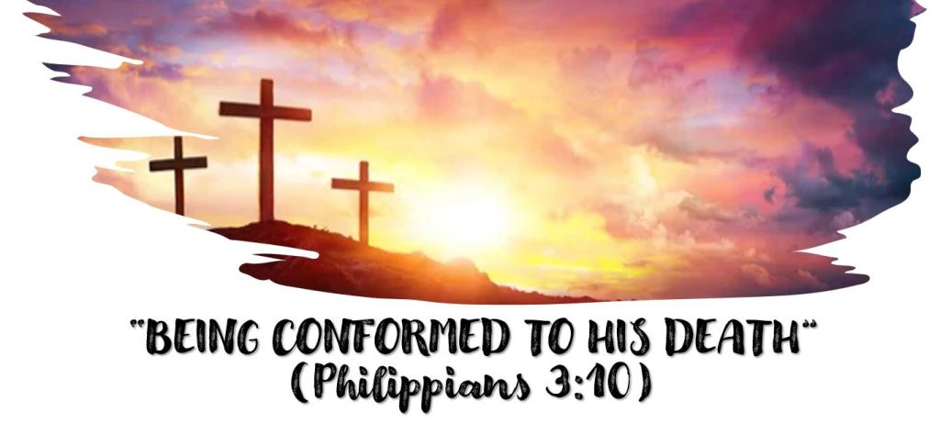
Christians are to follow the example of Jesus! Romans 8:29 tells us that it is God’s will that we be “conformed to the image of His Son”.
Philippians 3:9 tells us that we are to conformed to His death.
The theme of our class is “The cross is not just something we are grateful for, it is an _________________________ that we are to follow”.
Someone said, “We can manage our valleys by studying how Christ managed His” and last week we studied how Jesus managed the valley of great sorrow he felt in anticipating His death on the cross. What did we learn from His example?
THE CROSS TEACHES ABOUT UNITY
Text: Philippians 2:1-9
What desire does Paul express for the church at Philippi? (verse 2)
How does David describe unity? (Psalm 133:1)
What does Jesus say about the importance of unity? (John 17:21)
What does Paul say about unity later in Philippians 2? (2:14 and15)
What are some of the important attitudes we must have to maintain unity? (Philippians 2:3, 4).
To attain unity who are we to be like? (Verse 5)
How would you summarize the mind and behavior of Jesus described in 5-8?
What was the outcome of Jesus humbling himself as he did and how might this apply to us? (Philippians 2:9, 1 Peter 5:6)
Share any thoughts, comments, or questions you have in the reply section below. Join us Wednesday night for virtual Bible class and a review of this material.

