THE CHOSEN, Season 3, Episode 4
For Wednesday October 25, 2023

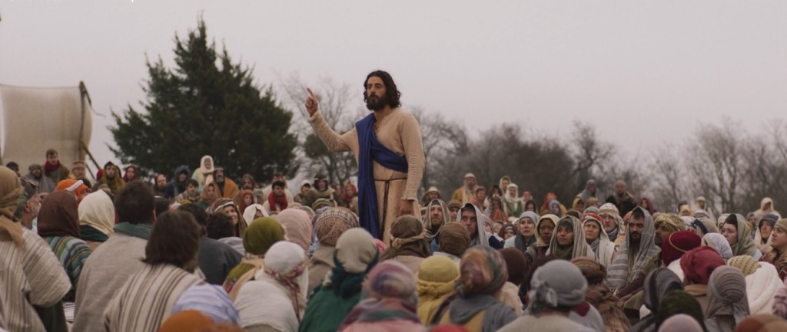
This episode is entitled “Clean”, which a reference to the Jewish purity laws from the book of Leviticus 15.
The episode begins with scenes from when the apostles were sent out two by two, preaching and performing miracles. What caught your attention about the way these events were presented?
In “Clean,” we meet a woman who has suffered from a constant flow of blood for an agonizing 12 years, and we learn more about Jairus, the ruler of the synagogue. This is a two part episode and their stories will intersect in next week’s lesson. Note how these characters are introduced Luke 8:40-43. Tell a little bit about how The Chosen is developing their characters.
The Episode also contains scenes in the Jewish synagogues where the purity laws (clean and unclean) are being read. How many other references to these Jewish purity laws can you spot in this episode?
Finally, does the drama being developed between Mary Magdalene and Tamar, and Peter and Eden seem feasible? Why do you think The Chosen is playing up these ideas?
Thanks for joining our Bible study! We will review this material together on Wednesday October 25 at 7 pm. You can participate in person or tune in via Facebook Live, using the provided link elsewhere on this page.

